**ELECTIVE 3: FULLSTACK WEB DEVELOPMENT**

**PRELIMINARY EXAMINATION**

**1st Semester, Academic Year 2019-2020**

Please follow the directions for each section. Note that in each section you will have some amount of choice in the questions you’ll be answering. The exam is based on a 100-point scale. Partial credit will be given for answers that are done partially well.

**Programming** (50 points ).

1. Create a basic website (without JavaScript) that has the following layout below with the ff. Instructions
   1. Should be posted in Github with the format E3PE_LASTNAME_FIRSTNAME for the project name.
   2. Follow layout below:

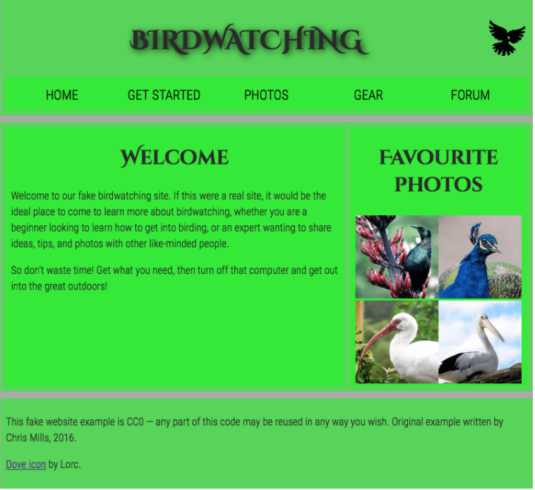

* 1. Logos and pictures can be changed.
  2. Fonts can be altered.

**Essay** (25 points):

1. How would you say that front-end development has evolved over the years? State some key difference from then (like 10 years ago) to now.

Front-end development has evolved over the years the only design that there is mostly tables and division for the front end, and image aren’t even intended the proper sizing.

Over the past few years, the role of the frontend development has evolved, user interfaces, With the fast and growing changes of tools and technologies, the web design techniques today are terrifically different from the first website published. The frontend is exciting not only visually, but also from a programming standpoint.

With recent years, Designing and creating a website is more convenient thru the use of software (that is available online) to make things simple but responsive, and now there’s a ruling for web design to make it really good and a lot more different kind of design.

it makes our daily basis activities easier.

1. Provide a code snippet that shows CSS precedence between element selectors, class selectors and inline styling.

* **Inline** - by using the style attribute inside HTML elements
* **Internal** - by using a <style> element in the <head> section
* **External** - by using a <link> element to link to an external CSS file

**Inline CSS**

<h1 style="color:blue;">A Blue Heading</h1>

<p style="color:red;">A red paragraph.</p>

**Internal CSS**

<!DOCTYPE html>

<html>

<head>

<style>

body {background-color: powderblue;}

h1 {color: blue;}

p {color: red;}

</style>

</head>

</html>

**External CSS**

<!DOCTYPE html>

<html>

<head>

<link rel="stylesheet" href="styles.css">

</head>

</html>

**External CSS ID or class**

.className {

color: #660600;

}

#idName {

font-size: 15px;

}

**EXTERNAL CSS TAG SELECTORS**

*

body {

background-color: blue;

}

h1 {

color: blue;

}

|  |  |  |
| --- | --- | --- |
| Prepared By:  NINO FRANCISCO ALAMO  Professor /Instructor | Reviewed By:  REGIE ELLANA  CCS Dean | Approved By:  DR. LEAH DIGO  VP for Academic Affairs |

|  |
| --- |
| **LOA-OAA-TOS-028** |
| **10-02-2020 | REV. 00** |

|  |  |
| --- | --- |
| **CODE** | **ELEC323** |
| **TITLE** | **ELECTIVE 3: FULLSTACK DEVELOPMENT** |
| **EXAM** | **PRELIMINARY EXAMINATION** |
| **TERM/AY** | **2ND SEMESTER, ACADEMIC YEAR 2019-2020** |

|  |  |  |  |  |  |  |  |  |
| --- | --- | --- | --- | --- | --- | --- | --- | --- |
| **Topic #** | **Objectives** | **Remember** | **Understand** | **Apply** | **Analyze** | **Evaluate** | **Create** | **Total # of Items/points** |
| 1 | * To apply the concepts of MVC   + - * + Creating Views         + Persisting to Database | 2 | 2 | 2 | 1 | 1 | 2 | **10** |
| **Total # of items/Points** | | 2 | 2 | 2 | 1 | 1 | **2** | **10** |

|  |  |  |
| --- | --- | --- |
| Prepared By:  NINO FRANCISCO ALAMO  Professor /Instructor | Reviewed By:  REGIE ELLANA  CCS Dean | Approved By:  DR. LEAH DIGO  VP for Academic Affairs |